.
La mer
qu'on voit danser le long des golfes clairs
a des reflets d'argent,
la mer,
des reflets changeants
sous la pluie.

La mer
au ciel d'été confond
ses blancs moutons
avec les anges si purs,
la mer bergère d'azur
infinie.

Voyez,
près des étangs,
ces grands roseaux mouillés.
Voyez,
ces oiseaux blancs
et ces maisons rouillées.

La mer
les a bercés
le long des golfes clairs
et d'une chanson d'amour,
la mer
a bercé mon cœur pour la vie.

mare
che lungo golfi chiari vediamo danzare
ha riflessi d’argento,
il mare,
riflessi cangianti
sotto la pioggia.

Il mare
al cielo estivo confonde
i suoi cavalloni bianchi
con i più puri angeli.
Il mare, mandriano d’azzurro
infinito.

Guardate
nelle paludi
quelle alte canne bagnate,
guardate
quegli uccelli bianchi
e quelle case arrugginite:

il mare
li ha cullati
lungo golfi chiari.
E con una canzone d’amore
il mare
ha cullato il mio cuore per tutta la vita

Ama la vita così com'è
amala pienamente, senza pretese.
Amala quando ti amano o quando ti odiano.
Amala quando nessuno ti capisce,
o quando tutti ti comprendono.
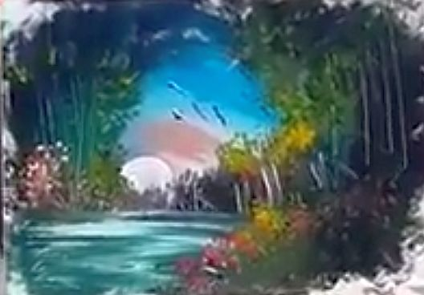

Gli spartiti che seguono sono alcuni di quelli che tentiamo di usare nelle nostre interpretazioni!

Diamante:
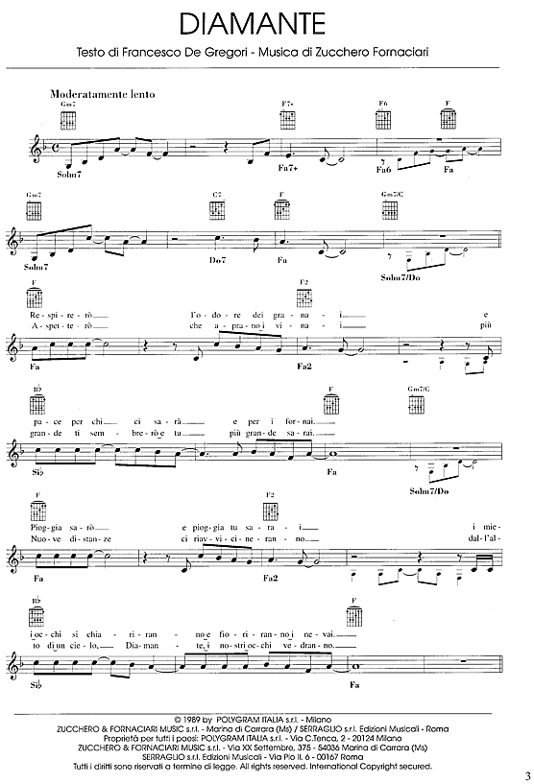

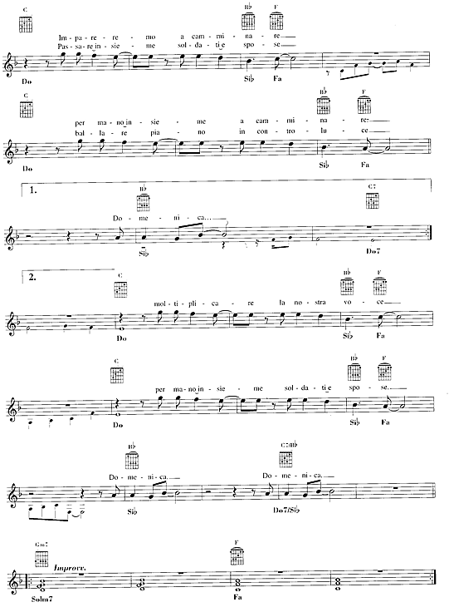
F Dm Am Dm
F Dm Am Dm
F Dm Am Dm
F Dm Am Dm

F Dm Am Dm D7 F#dim D7
Though the days are long, twighight sings a song
G7 Bb C F Dm Am Dm
Of the happin - ess that used to be
Am E7 Am
Soon my eyes will close, soon I'll find repose
Dm G7 C CM7 C7
And in dreams, you're always near to me

CHORUS

Bb Gm Bbm F E7(2) F6(2)
I'll see you in my dreams, hold you in my dreams
D7(3) G7 C CM7 C7
Someone took you out of my arms,still I feel the thrill of your charms
Bb Gm Bbm F E7(2) F6(2)
Lips that once were mine, tender eyes that shine
D#maj(4) Dmaj(3) C(2) A7 Dm
They will light my way to - night
Bb C F
I'll see you in my dreams

CHORUS INSTRUMENTAL

Bb Gm Bbm F E7(2) F6(2)
D7. . . . . . . . . . . . . .
G7 . . . . . . . . . . . . . .

Bb Gm Bbm F E7(2) F6
Lips that once were mine, tender eyes that shine
D#maj(4) Dmaj(3) C(2) A7 Dm
They will light my lonely way to - night

Bb C F
I'll see you in my dreams
D#maj(4) Dmaj(3) C(2) A7 Dm
They will light my lonely way to - night
Bb C F
I'll see you in my dreams
F Dm Am Dm
F Dm Am Dm THIS LINE SLOWS DOWN
XXXXXXXXXXXXXXXXXXXXXXXXXXXXXXXXXXXXXXXXXXXXXXXXXXXXXXXXXXXXXXXXXXXXX

Lo spartito professionale me lo trovo altrove . . . .

Voglio tutte le sfaccettature armoniche
della versione di Joe Brown!

